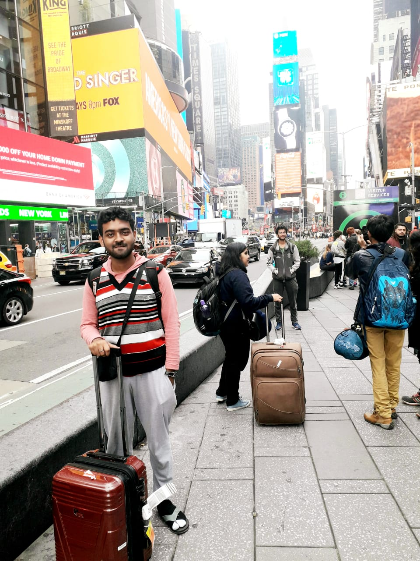 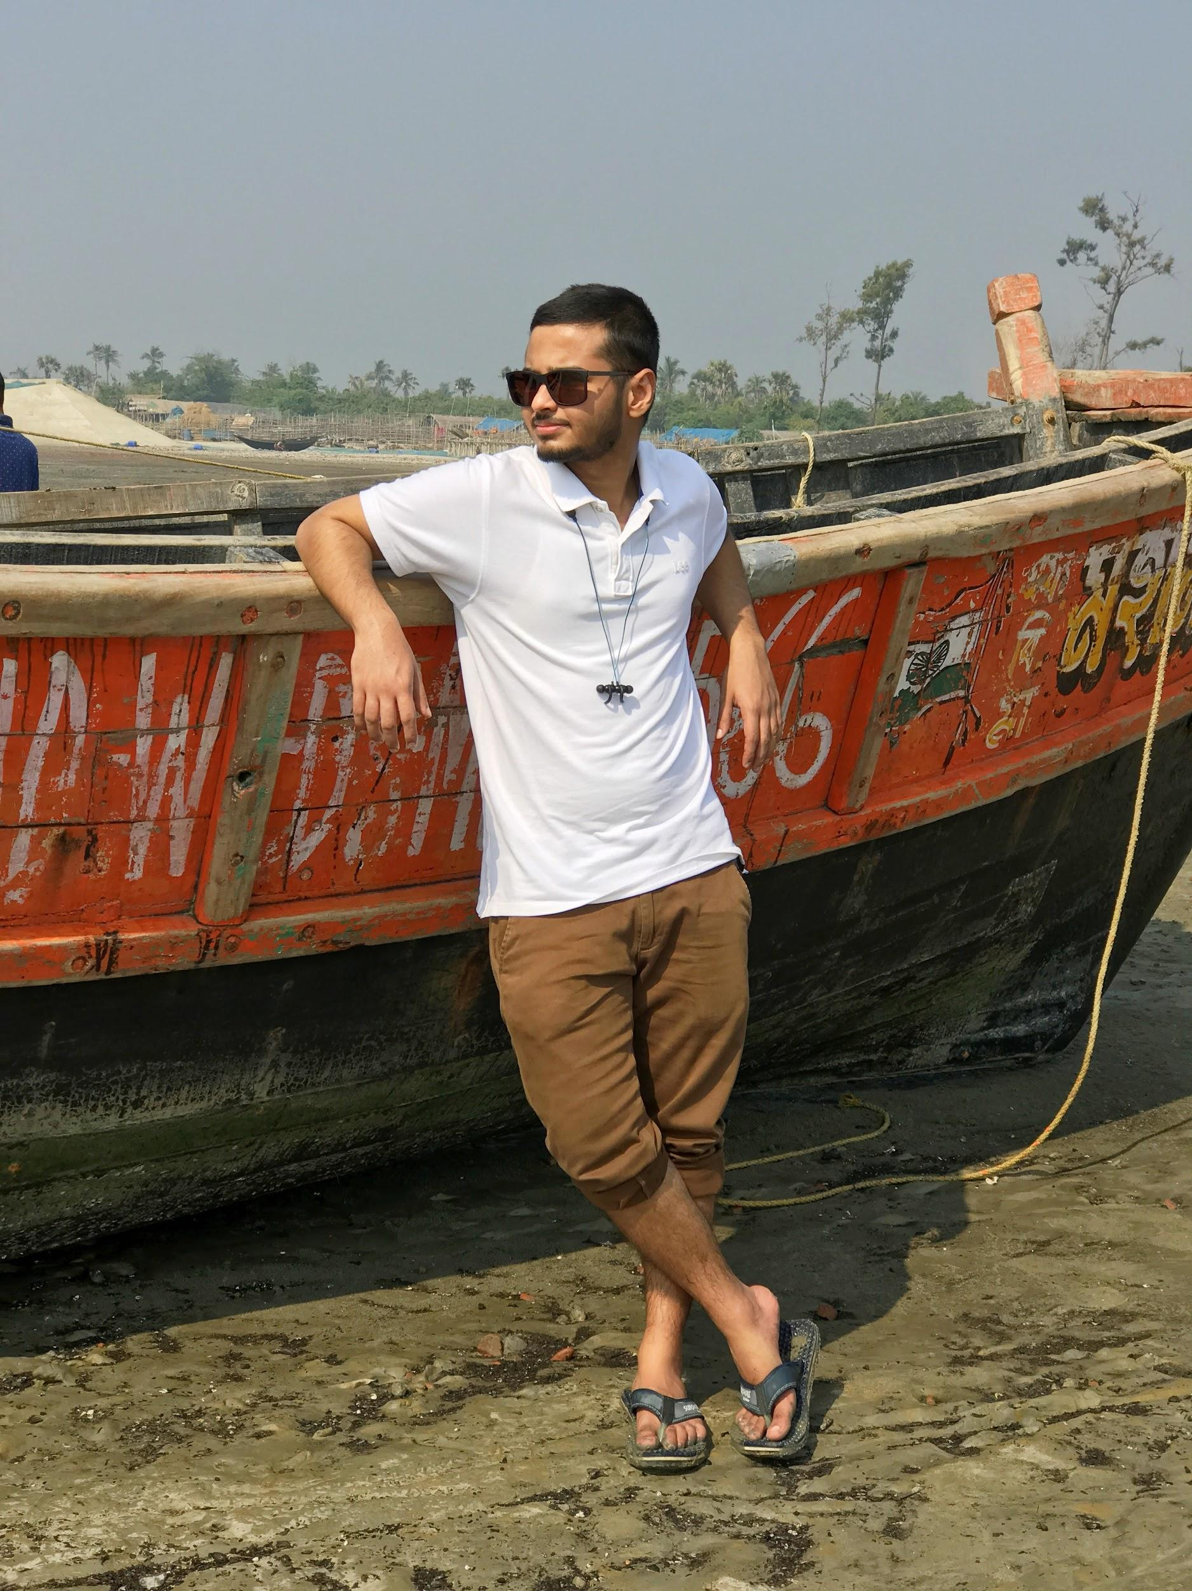

Sumit garai, Diptatanu Das,

Public Relations Officer Chief Executive Officer

BS-MS Student, Third year (18MS) BS-MS Student, Fourth year (17MS)

DBS DBS

“Bring something incomprehensible into the “Don't work to follow others. Work so that world!” others can follow you.”

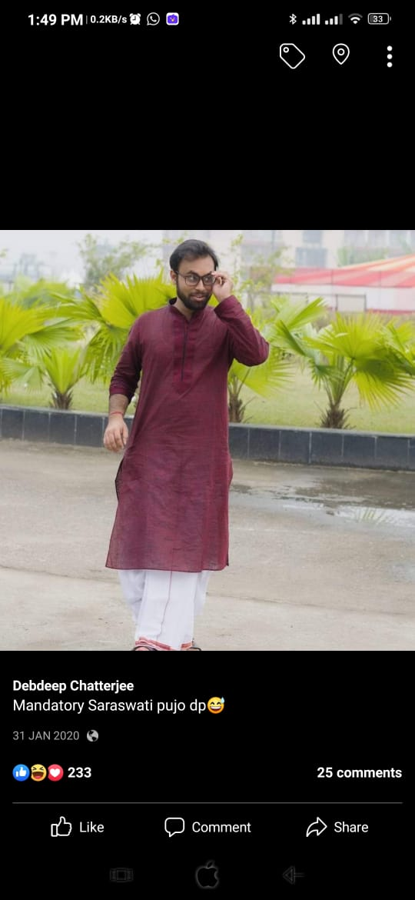

Debdeep Chatterjee

Chief Financial Officer

BS-MS Student, Fourth Year (17MS)

DBS

“Your future depends on your dreams,

so go to sleep”

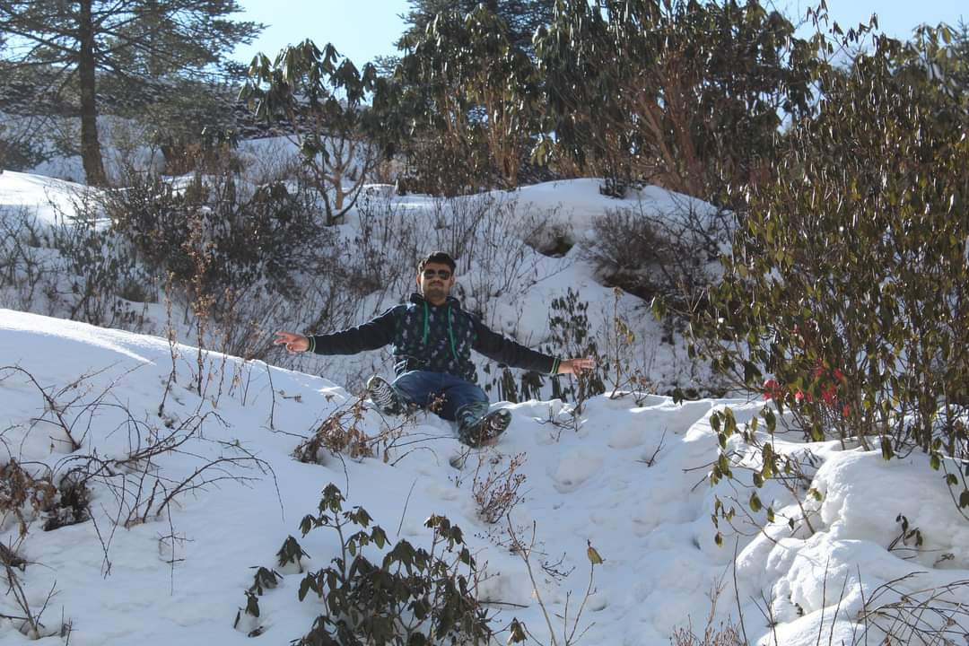

Akhil Kumar Nandi

Public Relations Officer

BS-MS Student, Fourth Year (17MS)

DPS

“ Good things take time”

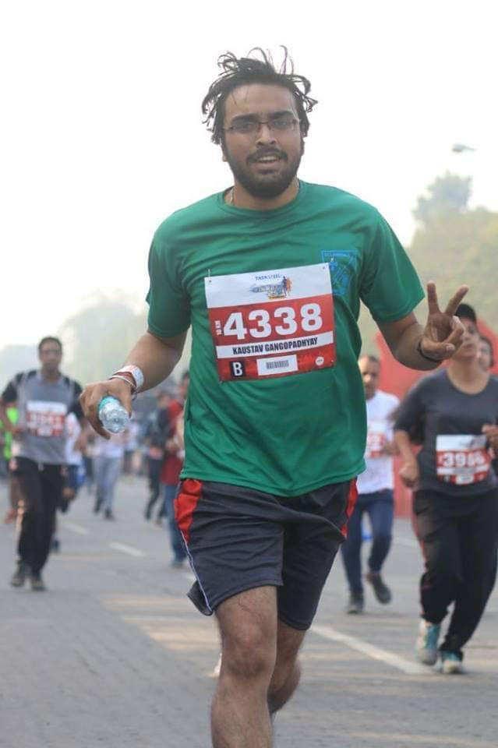

Kaustav Gangopadhyay

Chief Operating Officer.

PhD Student (15RS), DBS

“Make everyday a little less ordinary”

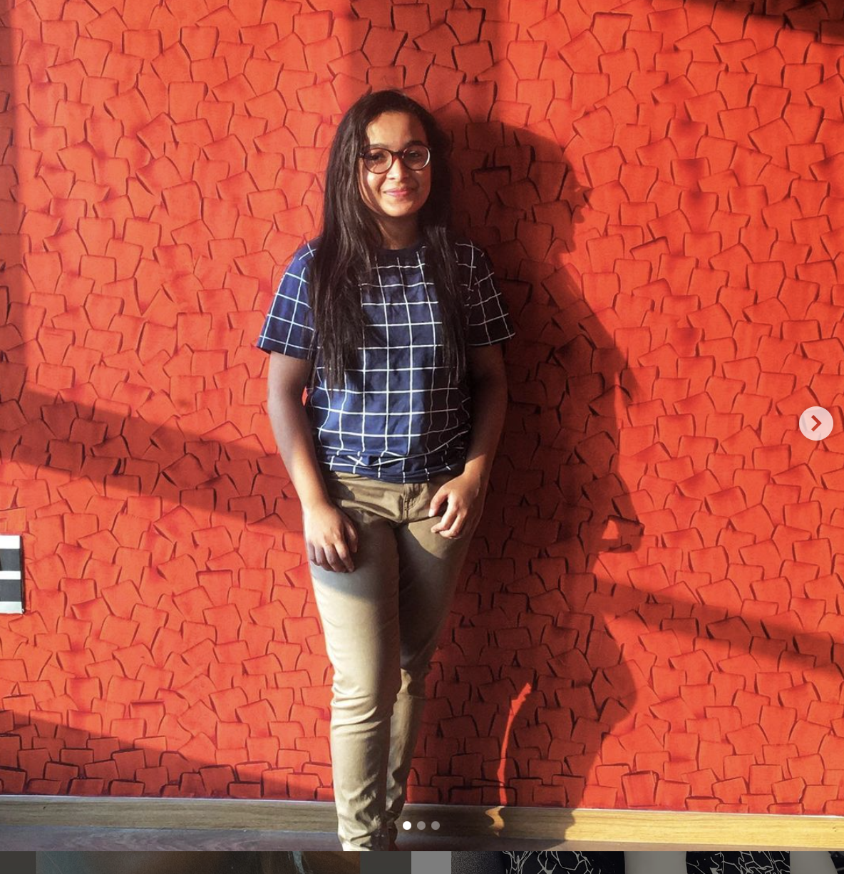

Adrija Adhikary

Chief Operating Officer

BS-MS Student, Second year (19MS)

“Practise like you have never won,

perform like you have never lost”